**Group A**

**Experiment No:** 2

**Aim:** Write a program to implement Huffman Encoding using a greedy strategy.

**Theory:**

Huffman coding is a lossless data compression algorithm. The idea is to assign variable-length codes to input characters, lengths of the assigned codes are based on the frequencies of corresponding characters. The most frequent character gets the smallest code and the least frequent character gets the largest code.

The variable-length codes assigned to input characters are Prefix Codes, means the codes (bit sequences) are assigned in such a way that the code assigned to one character is not the prefix of code assigned to any other character. This is how Huffman Coding makes sure that there is no ambiguity when decoding the generated bitstream. Let us understand prefix codes with a counter example. Let there be four characters a, b, c and d, and their corresponding variable length codes be 00, 01, 0 and 1. This coding leads to ambiguity because code assigned to c is the prefix of codes assigned to a and b. If the compressed bit stream is 0001, the de-compressed output may be “cccd” or “ccb” or “acd” or “ab”.

***Steps to build Huffman Tree***  
Input is an array of unique characters along with their frequency of occurrences and output is Huffman Tree.

1. Create a leaf node for each unique character and build a min heap of all leaf nodes (Min Heap is used as a priority queue. The value of frequency field is used to compare two nodes in min heap. Initially, the least frequent character is at root)
2. Extract two nodes with the minimum frequency from the min heap.  
   Create a new internal node with a frequency equal to the sum of the two nodes frequencies. Make the first extracted node as its left child and the other extracted node as its right child. Add this node to the min heap.
3. Repeat steps#2 and #3 until the heap contains only one node. The remaining node is the root node and the tree is complete.  
   Let us understand the algorithm with an example:

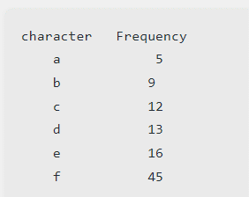

Step 1. Build a min heap that contains 6 nodes where each node represents root of a tree with single node.

Step 2 Extract two minimum frequency nodes from min heap. Add a new internal node with frequency 5 + 9 = 14.

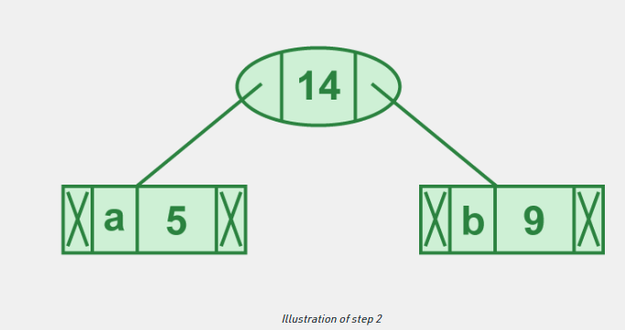

Now min heap contains 5 nodes where 4 nodes are roots of trees with single element each, and one heap node is root of tree with 3 elements.

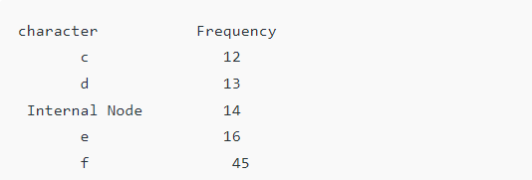

Step 3: Extract two minimum frequency nodes from heap. Add a new internal node with frequency 12 + 13 = 25

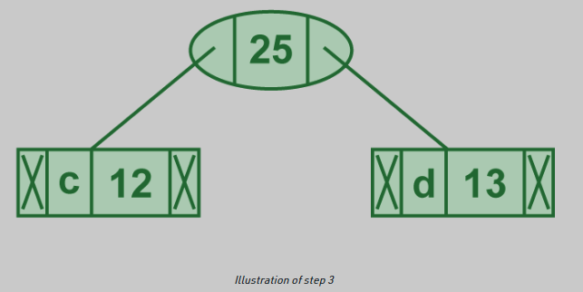

Now min heap contains 4 nodes where 2 nodes are roots of trees with single element each, and two heap nodes are root of tree with more than one nodes

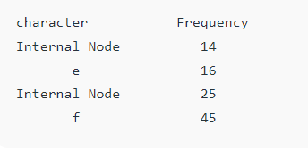

Step 4: Extract two minimum frequency nodes. Add a new internal node with frequency

14 + 16 = 30

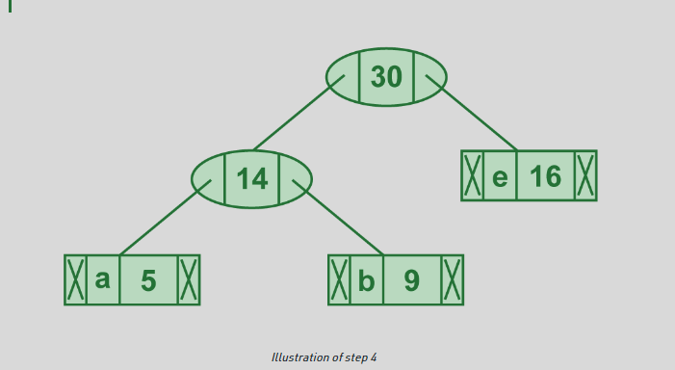

Now min heap contains 3 nodes.

character Frequency

Internal Node 25

Internal Node 30

f 45

Step 5: Extract two minimum frequency nodes. Add a new internal node with frequency 25 + 30 = 55

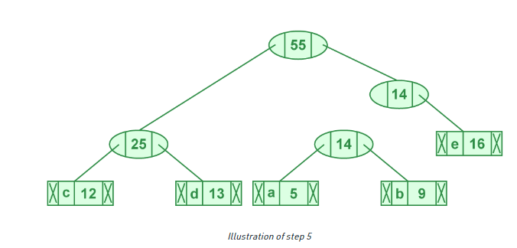

Now min heap contains 2 nodes.

character Frequency

f 45

Internal Node 55

**Step 6:** Extract two minimum frequency nodes. Add a new internal node with frequency

45 + 55 = 100

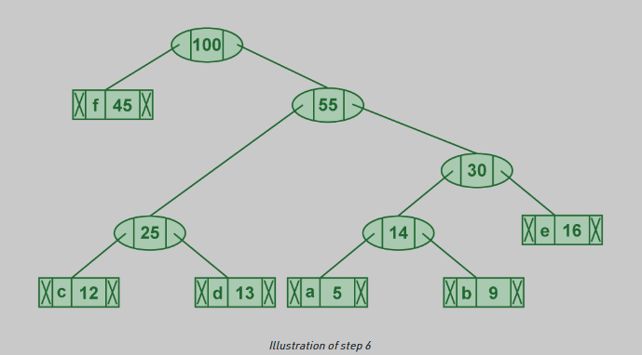

Now min heap contains only one node.

character Frequency

Internal Node 100

Since the heap contains only one node, the algorithm stops here

***Steps to print codes from Huffman Tree:***  
Traverse the tree formed starting from the root. Maintain an auxiliary array. While moving to the left child, write 0 to the array. While moving to the right child, write 1 to the array. Print the array when a leaf node is encountered.

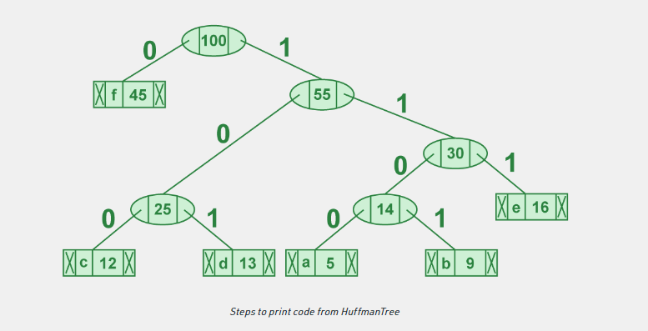

The codes are as follows:

character code-word

f 0

c 100

d 101

a 1100

b 1101

e 111

**//Code for Huffman Encoding in Python**

# A Huffman Tree Node

import heapq

class node:

  def __init__(self, freq, symbol, left=None, right=None):

    # frequency of symbol

    self.freq = freq

    # symbol name (character)

    self.symbol = symbol

    # node left of current node

    self.left = left

    # node right of current node

    self.right = right

    # tree direction (0/1)

    self.huff = ''

  def __lt__(self, nxt):

    return self.freq < nxt.freq

# utility function to print huffman

# codes for all symbols in the newly

# created Huffman tree

def printNodes(node, val=''):

  # huffman code for current node

  newVal = val + str(node.huff)

  # if node is not an edge node

  # then traverse inside it

  if(node.left):

    printNodes(node.left, newVal)

  if(node.right):

    printNodes(node.right, newVal)

    # if node is edge node then

    # display its huffman code

  if(not node.left and not node.right):

    print(f"{node.symbol} -> {newVal}")

# characters for huffman tree

chars = ['a', 'b', 'c', 'd', 'e', 'f']

# frequency of characters

freq = [ 5, 9, 12, 13, 16, 45]

# list containing unused nodes

nodes = []

# converting characters and frequencies

# into huffman tree nodes

for x in range(len(chars)):

  heapq.heappush(nodes, node(freq[x], chars[x]))

while len(nodes) > 1:

  # sort all the nodes in ascending order

  # based on their frequency

  left = heapq.heappop(nodes)

  right = heapq.heappop(nodes)

  # assign directional value to these nodes

  left.huff = 0

  right.huff = 1

  # combine the 2 smallest nodes to create

  # new node as their parent

  newNode = node(left.freq+right.freq, left.symbol+right.symbol, left, right)

  heapq.heappush(nodes, newNode)

# Huffman Tree is ready!

printNodes(nodes[0])

**//OUTPUT**

f -> 0

c -> 100

d -> 101

a -> 1100

b -> 1101

e -> 111

**Conclusion:** Thus, we have successfully implemented Huffman Encoding in Python.